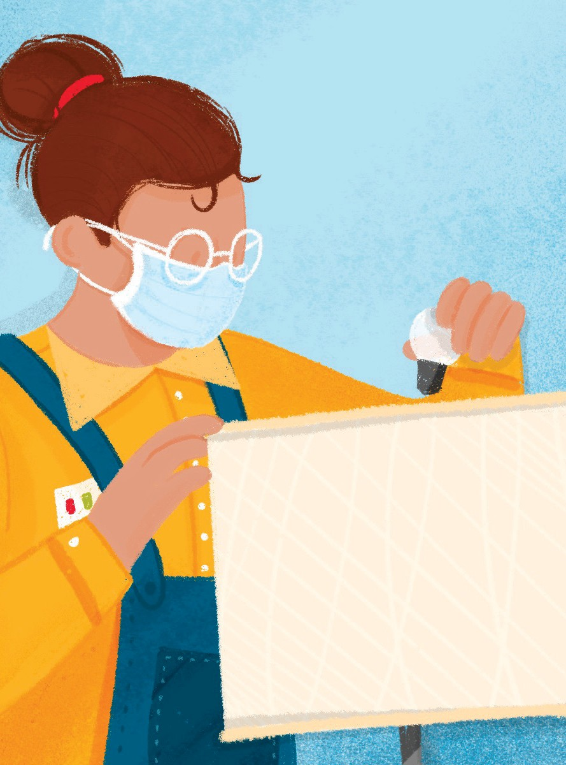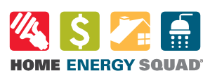

Tsev Hluav Taws Xob muaj kev daws teeb meem kev siv hluav taws xob zoo rau koj lub tsev.

Koj thawj kauj ruam yog peb qhov kev mus ntsib virtual \*. Kev mus ntsib dawb no yuav pab koj pom cov hauv kev txuag hluav taws xob tsawg. Yog tias koj lub tsev tuaj yeem tau txais txiaj ntsig los ntawm kev tuaj ntsib hauv tsev, peb yuav muab koj txuas rau qhov kev mus ntsib zoo tshaj plaws rau koj cov kev xav tau.

Peb muaj ob hom kev sib ntsib hauv tsev:

Mus Saib Txuag Hluav Taws Xob

Npaj rau cov tsev tshiab (tsim los ntawm xyoo 2000), cov tsev txawb, tsev so thiab tsev xauj.

Mus Sabi Cov Phiaj Xwm Hluav Taws Xob

Pom zoo rau cov tsev tsim ua ntej xyoo 2000.

Raws li qhov koj xav tau ntawm koj lub tsev, kev mus ntsib suav nrog kev teeb tsa cov khoom siv hluav taws xob txuag xws li lub teeb hluav taws xob LED, lub qhov rooj thiab nthab hle huab cua hle, qhov cuab yeej ntsuas sov, thiab cov dej ua hauj lwm kom zoo.

Tom qab koj tuaj ntsib koj yuav raug txuas nrog tus kws tshaj lij pab cuam hluav taws xob uas tuaj yeem pab koj nrog cov kauj ruam tom ntej los ntawm kev txuas koj nrog cov kws cog lus tsim nyog thiab them cov nqi hluav taws xob rov qab.

Mus ntsib dawb ywj siab rau cov yim neeg uas khwv tau nyiaj.

Xav paub ntau ntxiv thiab teem sij hawm must sib hu rau 651-328-6220 los sis mus saib mncee.org/hes.

\* Muaj kev sib tham hauv xov tooj yog xav tau.

Lub Nroog Minneapolis yog cov yuav txhawb nqa Pawg Hluav Taws Xob Hauv Tsev los ntawm kev yuav tus nqi. Tsev Hluav Taws Xob yog muab los ntawm CenterPoint Zog thiab Xcel Zog thiab xa los ntawm Lub Chaw rau Lub Zog thiab ib puag ncig (CEE), uas tsis yog hauv ib cheeb tsam.